Class I- Environmental Studies – 19/07/2019; Friday:
1. Which among the following does not spread light?
i. Sun ii. Electric Bulb
iii. Earth iv. Moon
2. Which among the following does not have beaks and feathers?
i. Parrot ii. Bat
iii. Crow iv. Hen
**********************************************

Class II- Environmental Studies – 19/07/2019; Friday:
1. Your father’s mother is your ________________
i. Grandmother ii. Aunt
iii. Uncle iv. Daughter
2. Which among the following is not a red vegetable?
i. Radish ii. Tomato
iii. Carrot iv. Beetroot
**********************************************
Class III- Science – 19/07/2019; Friday:
1. Which among the following is not a body part?
i. chin ii. cheeks
iii. chest iv. chicks
2. Which animal has a long neck?
i. Horse ii. Giraffe
iii. Zebra iv. Deer
**********************************************
Class IV- Science – 19/07/2019; Friday:
1. What is a telescope used for?
i. for seeing tiny objects for e.g. microbes
ii. for watching a match at the stadium
iii. for seeing the stars and planets in the space
iv. for viewing from a submarine
2. Which among the following are herbaceous plants?
i. Mint and Coriander ii. Rose and Hibiscus
iii. Banyan and Peepul iv. Neem and Babool
*********************************************
Class V- Science – 19/07/2019; Friday:
1. Which among the following units of measurements is an incorrect pair?
i. Heights & Lengths = Metres
ii. Weights = Grams & Kilograms
iii. Area = Cubic centimetres
iv. Distances= Kilometres
2. What do plants have that help them to trap solar energy? _________________
**********************************************
Class VI- Science – 19/07/2019; Friday:
1. i. The person who travels into the space is an
A_____________________ (9 letters)

ii Name the first astronaut to travel into the space
A__________________

2. i. B________________ (7 letters) are very tiny
microscopic living organisms.

ii. Name the microbe that helps in curd formation.
____________________________
*********************************************
Class VII- Science – 19/07/2019; Friday:
1. Which of the following is MOST likely to happen if there is excessive grazing on the same piece of land?
i. the soil will absorb more water. ( ) ii. the soil will become more fertile ( ) iii. the soil will undergo erosion fast. ( ) iv. the soil will become loose. ( )
2. Which among the following IS NOT a microscopic organism?
i. 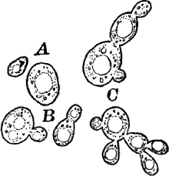 Yeast ( ) ii. 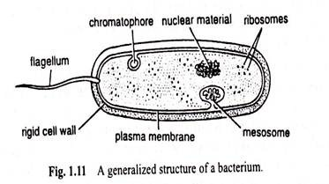 Bacterium ( )
iii. Insect Larva 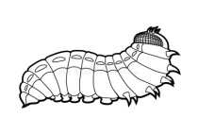 ( ) iv. 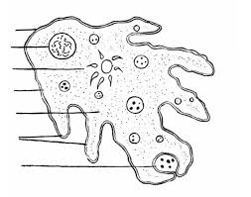 Amoeba ( )
****************************************************
Class VIII- Science – 19/07/2019; Friday:
1. Which among the following pairs IS INCORRECT?
i. Thomas Alva Edison- Electric Bulb ( ) ii. Michael Faraday- Laws of Electrolysis ( )
iii. Newton- Static Electricity ( ) iv. Darwin- Theory of Evolution by Natural Selection ( )
2. Which among the following IS NOT LIVING?
i. bone of a dead fish ( ) ii. heart of a new born baby ( )
iii. muscles of a galloping-horse( ) iv. hairs and nails of human beings( )
**********************************************
Class IX - Science – 19/07/2019; Friday:
1. ‘Those who conduct research in science are:-
a. Researchers [ ] b. Scientists [ ]
c. Entrepreneurs [ ] d. Pathologists [ ]

2. Which among the following is not an eye defect?
a. Short- sightedness [ ] b.Far sightedness [ ]
c. Astigmatism [ ] d. Visionary [ ]
****************************************************

Class X - Science – 19/07/2019; Friday:
Expand these abbreviations:
1. DDT ____________________________________________________
2. ADP ____________________________________________________

****************************************************

Class XI - Science – 19/07/2019; Friday:
1. ‘Time Machine’ is a science fiction authored by which among the following
a. Jules Verne [ ] b. H G Wells [ ] c. Leo Tolstoy [ ] d. Walter Scott [ ]
2. Which among the following pairs is incorrect?
a. cardiologist- heart [ ]
b. orthopaedic surgeon- bones and joints [ ]
c. neurologist- nerves [ ]
d. paediatrician- adults [ ]
**********************************************************

Class XII - Science – 19/07/2019; Friday:
1.‘Around The World In Eighty Days’ is a science fiction authored by:-
a. Jules Verne [ ] b. H G Wells [ ]
c. Leo Tolstoy [ ] d. Walter Scott [ ]

2. In 1924, Theodore Svedberg invented the
a. Sewing Machine [ ] b. Ultra-centrifuge [ ]
c. Microscope [ ] d. Telescope [ ]
**********************************************************

